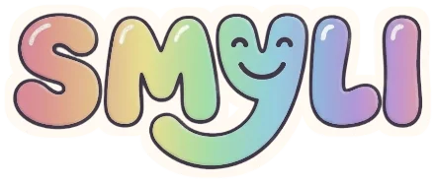
Face Painting Agreement
smyli.me • smylifaces@gmail.com • (720) 525-0134 • Dallas–Fort Worth
This agreement is between SMYLI and the client below. Date: __________________
Client
Name: ____________________________________________________________
Phone: ________________________ Email: ____________________________
Event
Event date: ___________________ Start / end time: __________________
Event type: ☐ Party ☐ Corporate ☐ Festival ☐ School or community ☐ Other
Location (venue or address): __________________________________________
Setting: ☐ Indoor ☐ Outdoor About how many kids: __________
Choose your package
☐ ECONOMY PLUS  $350  1.5 hours · up to 12 kids  Full design menu | ☐ BUSINESS  $485  2.5 hours · up to 20 kids  Custom theme to match your event
☐ FIRST CLASS  $195/hour  3-hour minimum ($585+)  Festivals, fairs, corporate events | ☐ HOURLY  Custom quote  Hours: ________  Rates at smyli.me
Final price: $______________ confirmed by email, including any travel fee
Good to know
• We bring everything. All paints, supplies, and our design menu. Each child picks a design.
• Safety. We use professional face paints and keep a clean, neat setup. We don’t paint over cuts, rashes, or sore skin. We are not responsible for allergic reactions or skin irritation. Face painting is at the client’s own risk.
• Insured. SMYLI is fully insured. An insurance certificate is available on request.
Photos (optional)
☐ Yes, SMYLI may use photos from the event for promotion.
☐ No, please don’t use photos.
Signatures
Client: ____________________________ Date: ______________________
SMYLI: ____________________________ Date: ______________________

